Actions for this week:
* Measure the remaining models on all four dimensions
* Organise the code and upload it to GitHub
* Organise the project process
* Conduct an in-depth analysis of RCCMix
* Show my supervisor the first draft of the literature review

What did I do this week? Why did I do this?
1. I completed the remaining measurements of model size, inference latency and energy consumption.
2. I organised all the code from my previous experiments and uploaded each part to GitHub.
3. I organised the project process, especially the weekly progress reports, written explanations, email correspondence with my supervisor, supervision meeting notes, and so on.
4. I carried out an in-depth analysis of RCCMix.
5. I sent the complete first draft of the literature review to my supervisor by email.
6. I prepared the presentation and submitted the slide deck on Aula.

Why:
1. The development of new models has now finished, and all 13 models have been successfully trained and tested on the RealWorld and LARa datasets. The only remaining task was to complete the measurements of model size, inference latency and energy consumption for the remaining models. Once this is done, the experimental work is essentially complete.

2. By uploading all source code to GitHub and then providing the repository link in the dissertation, I can demonstrate the authenticity of my work and give other researchers the opportunity to reproduce my experiments.

3. All evidence and materials for the project process must be organised early, and this has the highest priority. This is not only because the project process accounts for the largest share (40%) of the final mark, but also because the evidence and materials for the project process are extremely numerous and complex. Unlike the literature review and methodology, which are written in a relatively linear structure (for example, each section focuses on one topic), the weekly records in the project process often show that some ideas for experiments emerge from failures in previous weeks and adjustments made afterwards, which are linked to a lot of earlier work.

In addition, the weekly records of the project process are multi-threaded and cover many tasks running in parallel. Different tasks must be logically connected: things I did last week can affect several tasks planned for this week. Therefore, organising the project process requires more mental effort and concentration than writing the literature review or methodology. The project process also involves more detail: how each plan was made, adjusted and completed. This requires me to have detailed memory and records of what I did every week from 1 September up to now.

4. With 13 baseline models fully trained and tested on both datasets, and with accuracy, size, energy and latency reported for all of them, the next step is to highlight the contribution of my own models. For example, I need to explain why my proposed RCCMix can achieve such a high accuracy of 0.85, and analyse which modules contribute the most. This aligns with what my supervisor has repeatedly emphasised: it is not enough just to run the model and report the results – I also need to understand and explain why it behaves that way, why I chose certain components and how the model actually works.

5. Because the literature review in my proposal was very weak and my supervisor pointed out many problems, I need to take the literature review more seriously this time. Even though it only accounts for 20% of the mark, it still requires early and careful effort.

6. At this stage, the project is entering its final phase: the experiments are essentially complete, and most of my effort now goes into writing the dissertation and preparing the presentation.

Outcomes and findings:
1. I successfully completed the measurements of all models on accuracy, size, energy consumption and inference latency. The models covered are: KNN, Random Forest, InceptionTime, TST, MiniRocket, MultiRocket, rTsfNet, self-developed lightweight rTsfNet, RCCMix lightweight, RCCMix, DeepConvContext (Bi-Attention), DeepConvContext – LSTM unidirectional 1-layer, and DeepConvContext – LSTM 1-layer bidirectional (A100), for a total of 13 models.

2. I successfully organised all the code and uploaded everything to GitHub.

3. I finished organising the weekly project process from 1 September to 23 November.

4. I carried out an in-depth analysis of RCCMix, including visualising the FiLM modulation mechanism, quantitatively verifying rotation invariance, exploring multi-head attention patterns, and analysing the role of positional encoding.

5. My supervisor is currently on leave and said he will provide feedback on my literature review early next week.

6. I submitted the presentation slides on Aula and planned what I am going to say. I also played the role of my own examiner, asking myself questions and answering them. In fact, since early November I have occasionally been doing this self Q&A exercise to prepare for the presentation question-and-answer session and to train myself.

Reflection:
1. When measuring model size, the outputs include: total number of parameters, number of trainable parameters, and theoretical FP32/FP16 weight size. The number of parameters and the weight file size depend only on the network architecture itself (number of layers, channels per layer, hidden dimensions, etc.) and the parameter precision (fp32 / fp16 / int8). They basically do not change with the dataset, so this measurement is relatively simple and does not necessarily have to be done during training. The only case that changes it is when I modify the input channels or the number of classes to adapt to a specific dataset, but in essence that is already no longer “exactly the same model”, so of course the size will change.

For single-sample inference latency and single-sample energy consumption, in theory they are the same across datasets, and in practice the differences are tiny. If I strictly control all of the following to be identical – same hardware (same GPU/CPU), same framework and version (same TensorFlow/PyTorch environment), same batch size (for example, batch=1), same input shape (for instance, 3-second window × 50 Hz × 6 channels → 150 × 6), and I turn off all kinds of printing, logging and data augmentation so I only measure the pure forward pass – then, for the same model, the FLOPs per window are fixed. Therefore, in theory, the inference time (latency) and energy per sample are almost identical and do not change depending on which dataset the sample comes from.

Finally, for the same model, the energy per unit time (power) is usually approximately a hardware property and does not vary much. Under the following conditions: same GPU/CPU, same framework and version, same input shape (same window length and same number of channels), same batch size (for example, batch=256 during continuous inference), for a given model, the average power P of the GPU/CPU under sustained high-load inference is mostly determined by the hardware itself and whether it is fully utilised, and has very little to do with “which dataset the sample comes from”.

For these reasons, as long as I kept the hardware and inference settings the same, I did not insist on measuring energy, size and latency for all 13 models on one specific dataset. This was mainly for convenience and to save time, so that I did not have to re-run the full preprocessing pipeline for a specific dataset. However, I am confident that the energy, size and latency measurements I obtained for the 13 models are reliable.

2. After finishing the upload of all code to GitHub, I felt much more relaxed, because among all parts of the project, I think the coding/programming is the hardest, even harder than organising the project process. When running code, training models and designing new models, the most stressful thing is dealing with all kinds of errors, repeatedly fixing them and waiting for runs to finish. Previously I even kept my computer on for three days straight, with code running for 70–80 hours in a row, because some latent bugs only appear very late in a long run.

3. The project process is now more or less organised; I literally typed tens of thousands of words by hand. This week I originally planned to show my weekly project process documents to my supervisor during the meeting. However, he took sick leave this week, so I could not show them to him or get feedback on the format. That means I have to be flexible and imaginative on my own, and think about what else I can supplement or improve.

4. At the moment I have used 13 models in total, or 14 if I count the LARa-adapted version of RCCMix lightweight. I had originally thought about whether I needed to provide in-depth analyses (for example, confusion matrices) for fast and lightweight models like KNN, Random Forest or MiniRocket. But considering the limited time and large number of models, if I tried to do in-depth analysis for every single one, the dissertation would become overloaded with information and even my supervisor might find it overwhelming to read. Therefore, I decided to focus in-depth analysis on my self-developed models, because they represent my main contribution, while the other models essentially act as baselines that provide context for my models.

However, there is a problem: the in-depth analysis for the same model differs across datasets and folds. So, in terms of datasets, I decided to focus only on RealWorld for two reasons. First, RCCMix achieves its highest accuracy on RealWorld (0.85), which is far higher than the other models, so there is a lot to analyse there. Second, all models perform relatively poorly on the LARa dataset, with accuracies below 0.5. (In my Week 8 (3–9 November) document, I noted that “LARa MbientLab right wrist = fine-grained warehouse picking/packing actions + single wrist IMU”, which is widely considered a very difficult scenario. The official baseline tCNN on LARa-MbientLab reports a mean F1 of only about 0.53, and that is already regarded as one of the “state-of-the-art baselines”.)

5. Although my supervisor is on leave and will only be able to read my literature review draft next week, as he said in the meeting on 13 November, the project process is meant to evaluate whether I can continue to drive a large amount of concrete work forward even when there are no meetings. So I plan to work on other tasks first and keep time available later for revising the literature review once I have his feedback.

6. I have already asked my supervisor what questions I am most likely to be asked about my experimental pipeline in the presentation Q&A, and he gave detailed answers. I will mainly prepare according to the types of questions he mentioned, and if I have extra time and energy, I will add preparation for some additional questions.

Have I finished last week’s actions? What percentage? If not, how to improve?
Completion rate: 80%
The in-depth analysis of RCCMix could be made more targeted, or pushed to a deeper level.
The project process documents are basically organised, but because my supervisor was on sick leave this week, I could not show him the format or ask for advice. So I need to think carefully on my own, without my supervisor’s help, about what can be supplemented or revised to make the structure of the project process more complete.

Actions for next week:
* Complete the first full draft of the dissertation
* If time allows, add more in-depth analysis and explanation of RCCMix

Email record with my supervisor Halloran:
I sent my supervisor the first draft of my literature review for him to read.
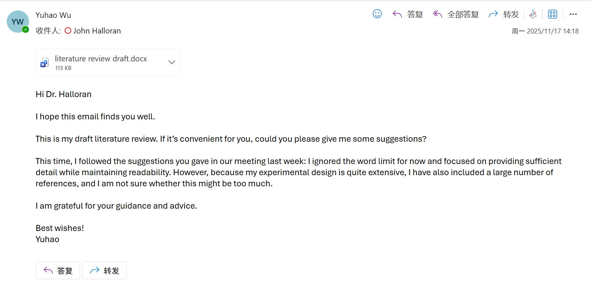
Because he has been very busy and has not yet replied, I planned to ask him about it in the meeting.

Meeting part:
My supervisor was not feeling well, so this week’s meeting was cancelled.

All the questions I originally planned to ask my supervisor:

My main concern is this.
I have trained and evaluated a total of 13 models on two datasets: 10 baseline models and 3 models that I designed myself. For all of these models I report accuracy, model size, energy consumption and inference latency. In addition, I have carried out some statistical analyses, comparisons, and in-depth analysis focusing on my own models, and I have produced some visualisations. It feels like the amount of experimental work I have done is several times that of a typical project, so does that mean my literature review also needs to be longer? On Monday I sent you a draft of my literature review. It is very detailed and rich in content, and it almost completely covers everything related to my experiments, but it is 16,000 words long.

If I try to explain all of the experiments I have done, especially the working principles of the models, and at the same time maximise readability, I feel that the whole dissertation might end up being around 30,000 words. I am not sure whether that would be too much. Although you mentioned before that students are not given lower marks simply for going over the word limit, I am worried that if I write 30,000 words it might also make it harder to achieve a high mark.

I am sorry, Dr Halloran, for asking about word counts once again. The reason is that I am considering applying for a PhD in the future if I get the opportunity, because I find research quite interesting. So even though I am not sure whether I can achieve it, I would really like to try my best to push my dissertation mark above 80, or even close to 90. I have already put a huge amount of work into this project, and I do not want that effort to go to waste.

Otherwise it would feel like a family who go out happily on Christmas Eve, buy lots of things and plan to have a party with friends in the evening, but on the way home they find the road completely blocked by traffic.

- Do I need to include some code and mathematical formulas in the dissertation, and explain them in depth with technical details? Would it be better not to include too much code and too many mathematical formulas?

- Can I use everyday-life analogies in my dissertation to explain things, or will that make it look informal? Example:
Heterogeneous timestamp alignment
The code uses pd.merge_asof for alignment.
Technical explanation: This is a “tolerance-based merge”. Since ACC and GYR data points are almost never generated at exactly the same nanosecond, we cannot use a normal join. merge_asof will, for each ACC timestamp, find the closest timestamp in GYR and pair them up.
Intuitive example: Imagine two people both keeping diaries. Person A writes every day at 08:01, and person B writes every day at 08:02. We want to stitch their diaries together into a single one. We cannot look for entries with exactly the same time; instead, we can only match entries that are “closest in time” to form a pair.

Presentation:
- When will I be informed of the time of my presentation?
- After I submit my presentation slides on the 24th, will I still be allowed to make some changes before the actual talk?
- Will we have a presentation template to use as a reference?

- My presentation structure:

Slide 1: What is human activity recognition, how is it done, and why is it important
Slide 2: What my research topics are, and why I chose to study these topics
Slide 3: The two datasets I use, Realworld and LaRa
Slide 4: Introduction of the six traditional baseline models I use (k-NN, Random Forest, InceptionTime, MiniRocket, MultiRocket, TST)
Slide 5: Introduction of the two state-of-the-art baseline models I use: rTsfNet (IMWUT 2024) and DeepConvContext (2025)
Slide 6: I combined the two state-of-the-art baseline models to develop my own model and briefly explain this model
Slide 7: I evaluated all models in terms of accuracy, model size, inference latency and energy consumption, and briefly report the results
Slide 8: What my contributions and originality are

Question:
What are the weaknesses of this structure, and how should I change it?

Project process：
Demonstrate the project process structure on GitHub
Can you open the file I send you?

My adjustments:
Because my supervisor was unwell and could not attend the meeting, I had to rely on myself to identify issues in the presentation structure and revise it accordingly. For the literature review, I need to wait for my supervisor’s feedback next week. Before that, I will start writing the dissertation, following the requirements my supervisor mentioned earlier: provide more explanations, give more examples, and try to finish the draft as early as possible so that he can review it and suggest revisions.

